Kevin Leugers, Robert Paponetti, & Alex White
Dr. Sarah Stitzlein
CI 3010-001
25 April 2015
Pathways to Literacy: A New Preschool Plan for Ohio
"Early-childhood nurturing has traditionally been the province of families. But families are deteriorating. Roughly one in six kids was born into poverty or single parenthood or both in 1970. In 2000, the rate was about one in four. What's more, almost 10 percent of children were born to unmarried teenage mothers in 1999; these kids tend to receive especially low levels of emotional and intellectual support and cognitive stimulation. They arrive at kindergarten cognitively disadvantaged, and the gap widens as they get older, eventually leading to early babies, lousy jobs, and elevated crime." - Joel Waldfogel (Professor, University of Minnesota)
“Okay. If you look at the research evidence -- that's extensive -- on how much early childhood programs affect the educational attainment, wages and skills of former participants in preschool as adults, you take those known effects, you take how many of those folks will be expected to stick around the state or local economy and not move out, and you take research on how much skills drive job creation, you will conclude, from these three separate lines of research, that for every dollar invested in early childhood programs, the per capita earnings of state residents go up by two dollars and 78 cents, so that's a three-to-one return.” – Timothy Bartik (Macroeconomist, Miami)

America is hurting. 30 years ago, America was the leader in quantity and quality of high school diplomas. Today, our nation is ranked 36th in the world. The federal and state governments are designing reform after reform in the hopes of fixing the educational problems in the United States. Charter schools and the competition established by No Child Left Behind have been applied to grade schools and high schools, attempting to revive the school systems. Independent organizations, such as Teach For America and numerous private foundations, have intervened in this nationwide effort. Although the attention and supplemental efforts are in good spirit, perhaps some of the momentum may be better directed elsewhere: preschool may, in fact, be the overlooked solution to many of society’s - and therein the government’s – prevailing mentalities. Public spending on education inadequately addresses the 90% of brain growth that occurs between ages 1-5 (Heckman, 2007). Moreover, substantial research has been published detailing how enrollment in quality preschool produces a relatively larger impact on children living below or at the poverty line, which then provides the opportunity to mitigate or eliminate the education gap associated to income by offering an equal starting ground (Gormley, W., Gayer, T., & Phillips, D.A., 2008). “Robust evidence suggests that a year or two of center-based ECE for three- and four-year-olds, provided in a developmentally appropriate program, will improve children’s early language, literacy, and mathematics skills” (Investing in Our Future, 2013). Preschool is the new frontier of education and is transitioning pre-k education from a luxury to a recognized necessity as evidenced not only by research but by federal support in the form of tax credit expansion and a super majority of public support (Weigel, 2014). Quality preschool would also address the demands of Ohio’s Third Grade Guarantee through the aforementioned literacy effects as well as language and mathematics skills. Therefore, because of the economic benefit, bipartisan support, and the educational gains, we hold that Ohio state legislatures should overtly deem preschool education to be necessary for all children both in their vote and in support of preschool expansion initiatives.
Before examining the best ways to improve literacy, it’s important to look at its current state and the effects that it has on the citizen population throughout the state and nation. Overwhelmingly, evidence on both the local and national level points to the need for increased literacy. According to a local study done by the Literacy Cooperative in Cleveland, 47% of people above the age of 16 in Cuyahoga County lack the necessary literary skills to write a brief letter explaining a credit card billing error or to use a bus schedule to choose the correct bus to get to work on time (“Advancing Literacy”, 2006). On a national level, 2/3 of children who cannot read proficiently by the end of fourth grade will end up in jail or on welfare (“11 Facts”). It’s no coincidence that this cutoff point corresponds closely with the Third Grade Guarantee, which stipulates that students need to score at a certain level on state tests to advance to the fourth grade. This age is crucial in the development of literacy, and represents a “tipping point,” in which “children have to make a critical transition from ‘learning to read’ to ‘reading to learn’” (“Initiatives from Preschool”, 2014). Therefore, because of its societal and governmental implications, the current state of literacy doesn’t spark a debate on whether improvement is necessary, but instead asks the question of the most effective way to achieve it.
Aside from the welfare and future of children, there is also a high public cost associated with low literacy. This point is proven especially well in the “The Economic Case for Literacy” released by The Literacy Cooperative in Cleveland. The study analyzed the expenditure in citizen support that occurs specifically in Cuyahoga County in Northeast Ohio. The results, as seen in Figure A below, demonstrate the additional spending that is necessary to support citizens with low-literacy when compared with their more proficient counterparts. The data is broken down into four main areas that experience the greatest amount of additional spending: healthcare, public assistance, corrections, and education. The area receiving the most additional money is clearly healthcare, which has an additional expenditure of $514 million based on the fact that citizens with low literacy average healthcare costs four times higher than those with proficient literacy (“The Economic Case”, 2011). Another important point to notice is the additional $20 million spent in education, specifically to remediate academic issues in children that have parents with low-literacy in the pre-K years (“The Economic Case”, 2011).
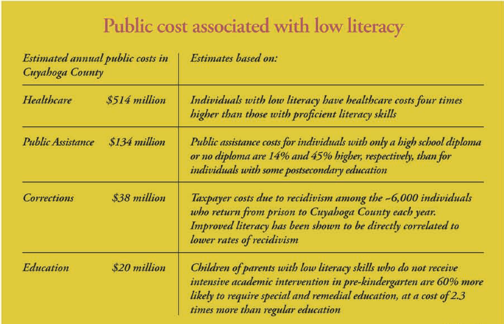
Figure A

It’s clear that across the board, public expenditure in Cuyahoga County is hugely increased when there is a lack of literacy among the citizen population. Altogether, the additional costs add up to $706 million, representing a huge opportunity for savings that the state is currently missing out on (“The Economic Case”, 2011). These estimates are based solely on the extra public expenditure in Cuyahoga County; if these estimates were to be expanded to include all of the counties in the state, the opportunity for savings would should increase significantly. In this way, the consideration of public cost associated with low literacy helps to demonstrate another dimension in the need for increased literacy in the state of Ohio.
Time and again, research has proven that healthy early childhood development connects closely with the development of literacy. In fact, it’s been documented through research that “investment in early learning and development is more efficient and can generate more benefits than costs relative to investment later in the life cycle” (Yoshikawa, 2013). Therefore, we believe that preschool exists as the best and most effective solution to the plague of low literacy in the state of Ohio. Studies have repeatedly found that preschool positively contributes to skill growth for both low and middle-income children in literacy, language, and mathematics (Yoshikawa, 2013). Additionally, it has positive effects on both socio-emotional development and physical health in young children (Yoshikawa, 2013). This strong and proven correlation between preschool and an increase of literary skills and developmental health across socioeconomic lines point to the potential benefits of preschool for young children and the prevention of later expenditure aimed at remediating a lack of essential skills.
The benefits of preschool can be more clearly seen through the examination of a study dedicated to investigating the effects of preschool programs on children throughout their lives. The 1962 Perry Preschool Study consisted of 123 children who were identified as being at-risk of school failure, meaning that they were living well below the poverty line and had parents with an average education level of ninth grade (Schweinhart, 2005). Of these children, 58 were randomly assigned to a high-quality preschool program while the other 65 did not participate in any program at all. These children were followed throughout their lives, and were evaluated, among other things, on homework performance, basic achievement, and high school graduation rates—all of which are heavily influenced by literary proficiency (Schweinhart, 2005). The results of this study are shocking, and create a strong case for preschool programs and the benefits associated with them. The most recent findings, released in 2005, are illustrated in Figure B below which shows the status of those who were enrolled in the preschool program compared to those who were not at age 40. Although all areas show positive impacts for those who were involved in a preschool program, the strongest case for the academic benefits of preschool can be derived from the increases in high school graduation rates, basic achievement at age 14, homework at age 15, and increased IQ of those who had the benefit of a preschool program (Schweinhart, 2005). These areas in particular demonstrate the improved academic foundation and increased skill growth that preschool can provide for young children, and the continuing positive effects that these kind of improvements can have for the duration of a child’s life.

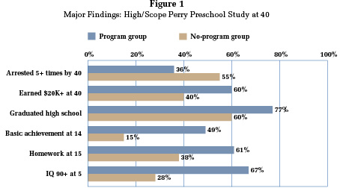
Figure B

Clearly, the life trajectory of a young child, specifically in the development of academic and literary skills, improves significantly with the early introduction of a preschool program. In this way, the expansion of preschool in the state of Ohio could effectively battle low literacy and improve the quality of life for citizens across socioeconomic lines.
Fortunately, efforts are currently being made to take advantage of such social opportunities, as Ohio is currently seeking to expand its investment in preschool programs. Many of the current preschool investments are realized through tuition credits to offset the high costs of preschool for lower income families (Ohio, 2012). While these programs are certainly worthwhile and represent a step in the right direction, their effectiveness is mitigated due to several key factors. Of utmost importance is accessibility: in order to receive a preschool tuition credit, families must complete an application procedure. In many cases, the parents of children most in need of preschool lack the basic skills necessary to successfully apply for a preschool tuition credit. Many of the children for whom preschool programs were designed are therefore unable to take advantage of them. In addition, many middle class families receive a relatively small tuition credit that does not sufficiently offset the cost of preschool to the point of affordability. Perhaps even more important, reliance on tuition credits detracts from the increasingly indisputable notion of the central necessity of preschool. From the age of five, children are required to be educated, and the costs of public education are completely assumed by governments. By funding preschool education through a tuition credit system, preschool is seen as a less important “extra” element of education, when it may in fact be the single most important contributor to a child’s academic and adult success. Finally, in most cases, tuition credits are applied to preschools outside of the public education system. It is difficult, therefore, for a state to regulate what is being taught in preschool and who is teaching it. The significance of teacher qualification regulation becomes remarkable when research indicates the strong effects of higher educational attainment of instructors.
In order to mitigate the effects of these issues within the current, tuition credit system, a significantly larger investment would be necessary. State or federal funds would have to be used to completely offset the cost of preschool for all families who are determined to be in need. Not only would the costs of tuition have to be covered, but also the associated costs of transportation, supplies, and uniforms when necessary. In addition, the state government would have to invest time and money to work with schools outside of the public education system to ensure than qualified teachers would be teaching a worthwhile preschool curriculum.
While it could be possible to invest enough capital in the existing tuition credit system to achieve the aforementioned results, a more efficient solution would be to “cut out the middleman” and simply expand the existing public education system to include preschool. Along with eliminating the issues related to the tuition credit system, expansion of public education would yield other significant benefits. First, students would be drawn into public education at an early age and would be more prepared for success throughout their public education careers. Through this increased preparation, public school students would be inherently stronger. The entire public school system would therefore be able to set higher standards and expect better results from all of its students. In many cases, education reform issues deal with a discrepancy between excellent and equity. Public preschool, however, offers a rare opportunity to bring an entire population to a higher level of excellence. Also, by incorporating preschool into public education, preschools would be inherently more integrated and community-representative than they are under the current tuition credit system, where many schools are catered to certain religious or socioeconomic populations.
The costs associated with such a universal public preschool initiative are difficult to estimate, although they are expected to be high. The previously discussed Perry Preschool Program required an initial investment of just over $15,000 (Schweinhart, 2005). Other tuition-credit-based programs in Cincinnati and Cleveland are estimated to costs around $20 million each (Pre4Cle, 2014 and Preschool Promise, 2015). Unfortunately, these cost numbers cannot be accurately extrapolated to the state level. First, all three of the programs operate through tuition credits, rather than an expansion of the public school system. A full-scale public system upgrade would likely require additional investments in preschool infrastructure, teacher certification, child transportation, etc. Furthermore, the three programs mentioned also involve much smaller student populations than a statewide preschool plan. Larger-scale programs generally feature lower costs per child than their small-scale counterparts. Despite the complicated interactions between these two phenomena, one estimate for an Ohio universal preschool plan has been offered: 2014 gubernatorial candidate Ed Fitzgerald championed a statewide preschool plan that would cost up to $600 million (Plain Dealer, 2014). At this time, however, such an estimate is considered unreliable, since neither the details of Fitzgerald’s plan nor the minutia of its cost analysis could be located.
From the Ohio River to the sunny shores of Erie, public support abounds for increased public investment in early childhood education, despite its high associated costs. The Preschool Promise seeks to make expanded access to high quality preschool for three and four year olds a ballot initiative by 2016 and has gained incredible momentum over the past two years (Preschool Promise, 2015). A similar program, Pre4Cle, will expand both access and capacity for high quality preschool in Cleveland (Pre4Cle, 2014). Both of these programs would require significant public spending, but have seen encouraging early success, indicating that Ohioans across the state see the value in early education investments. This sentiment is echoed in the results of a study conducted by the First Five Years Fund, which concluded that seven in ten Ohio voters support using state funds to increase early childhood education opportunities (Weigel, 2014). Furthermore, expanding early childhood efforts is supported by a majority of Ohio voters who affiliate as either Republican, Democrat, or independent (Weigel, 2014). These results, combined with the success of the aforementioned programs, indicate that Ohio voters, regardless of location of party affiliation, are ready and willing to seriously invest in expanded pre-K education.
Furthermore, teachers and their representative organizations have shown support for expansion of preschool and/or universal preschool. Robert Lynch, writing for the American Federation of Teachers, quoted the economic benefits of preschool and its effects upon children born into poverty in his argument for pre-k expansion. The National Education Association was also voiced its support through several articles and posts on preschool. Teach for America’s latest endeavor to send their workforce into early childhood education settings indicate T.F.A.’s recognition for the necessity of quality pre-k.
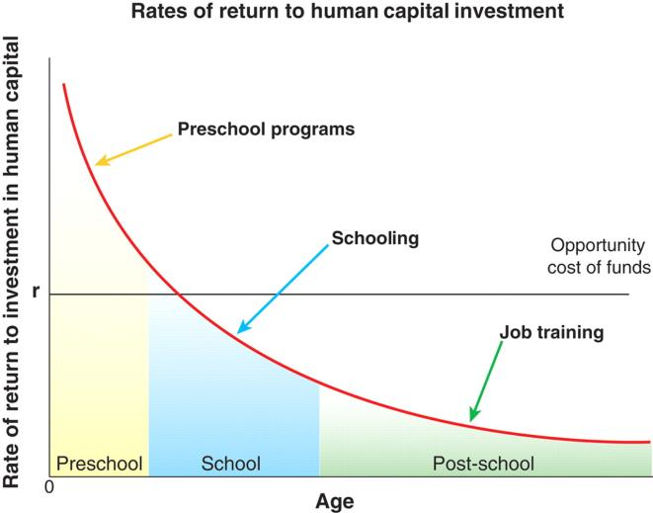
One likely reason for Ohioans’ widespread support of increased pre-K education initiatives is the incredible economic opportunities they provide. Nobel laureate and University of Chicago economics professor Jim Heckman investigated the return opportunities available for public investments made at different points in a person’s life. The results of his study are shown below in Figure C. It can be seen in Figure C that the expected returns on investments made early in a person’s life, in preschool programs for example, are exponentially higher than for investments made later in life on things like job training (Heckman, 2007). The horizontal line in the middle of the graph represents the opportunity cost of these investments. Essentially, this is the line of capital efficiency. Investments whose returns fall above this line are efficient, while those whose return fall below the line return less than other opportunities. From an investment standpoint, it is clearly more economically efficient to fund early childhood and thereby prevent potential problems instead of paying more to fix them later.
Figure C: Human Investment ROI
It should be noted that although investments whose returns fall below the opportunity cost line are not considered economically efficient, they cannot simply be stopped. Investments in middle and high school children, for example, are necessary in order to continue to pay for those elements of public education. Post-school training programs, although they offer the lowest direct returns, are also of particular importance because many of the adults in these programs are parents of young children. Studies have shown a strong link between a parent’s education, skills, and emphasis on education and the child’s affinity for success in areas like education and literacy (Carroll, 2013). Continued research is therefore needed to determine the “indirect returns” available from investments in parent training programs that could be realized through their children. Nonetheless, it can be determined from Figure B that investments in preschool programs are very economically efficient and can be expected to yield high returns.
The reason for this economic opportunity is very logical: a person’s brain develops almost entirely within the first few years of existence. According to Dr. Heckman’s research, approximately 90% of a person’s brain development has already occurred by the time a child is four years old (Heckman, 2007). By investing significantly into a young child’s education and well-being, therefore, a society can maximize the child’s potential for healthy development. As previously discussed, such an investment would increase the child’s affinity for key life skills, such as literacy, later in life, reducing many of the high costs associated with a lack of such skills (see in Table XX). Unfortunately, the current spending system is, on a national level, not designed to maximize this opportunity. Figure D (below) shows brain growth and public capital invested at each year in a child’s life. 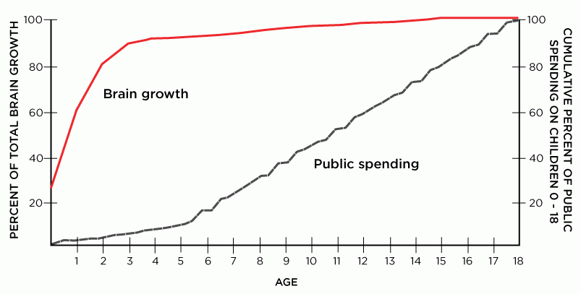
Figure D: Brain Growth and Public Spending
The red line in Figure D’s graph shows brain growth as a percentage of the total, while the black line represents the cumulative public investment also as a percentage of the total. It should be noted that the public spending graph represents not only investments in education, but also in child healthcare, social well-being, and other support programs. It can be seen from Figure D that very little public investment, about 10% of the total, is made each year during the first four years of a child’s life, when about 90% of brain development occurs. A significantly larger investment (indicated by a steeper black line) is made when a child is six years old and continues for the next twelve years (Heckman, 2007). Clearly, societies with this investment strategy are missing an opportunity to healthily and intelligently mold their citizens when they are able to be effectively permanently influenced. When such an opportunity is missed on a large scale, widespread developmental disadvantages that often reflect socioeconomic status can occur.
In contrast, when this investment opportunity is utilized, the social and economic benefits cannot be understated. The results of the Perry Preschool Study, shown previously in Figure D, demonstrate that investments made in children through preschool programs generate social benefits like higher high school graduation rates, better adult job salaries, and lower arrest incidents. While these results are in and of themselves key indicators of social progress, they also correspond to significant economic savings. Figure B (above) shows the economic results of the Perry Study when its participants were forty years old (Schweinhart, 2005). Figure B indicates that significantly lower public investments were required in preschool-program participants than in their non-program counterparts. In particular, public investments related to criminal behavior (lawyer fees, jail monies, rehabilitation, etc.) were over $170,000 lower for the Perry Study participants who had been placed in preschool programs. By the time the participants were forty years old, placement in preschool programs had generated a return of nearly $13.00 for every dollar invested. The incredibly high investment returns demonstrated by the Perry Study and other similar studies show the real-world efficiency of investing in early childhood programs.
Our group, therefore, is in support of preschool expansion because of the abundant research indicating the astounding returns from pre-k education. Furthermore, we are in support of enlarging the tuition credit system and implementation of universal preschool because the two models move in positive directions toward an economically wise and socially responsible service. We support both on the grounds of preschool expansion benefits, however, the current tuition credit system raises concerns on issues of esteeming pre-k as “extra” rather than necessary and the inaccessibility to preschool via application impositions or insufficient credits to make preschool affordable. Reform of the tuition credit system could produce desired effects, which would again draw our support, yet such an investment would appear to be better targeted toward universal preschool given that public preschool will result in certain economies of scale, the overseeing government would have more control on the critical components such as teacher quality, and it would further the integration of children across socioeconomic and various demographic backgrounds – a fundamental interest of the public school system. Therefore, we endorse the expansion and reform of the tuition credit system but hold that universal preschool would be the best allocation of funding. Furthermore, we recommend that state legislatures in Ohio proffer explicit support for preschool systems, increase the funding for public preschool programs, and develop a plan for the establishment of a public preschool program.
The argument for preschool appeals to many interest groups as indicated by the remarkably high percentage of Ohioan support. Preschool has demonstrated its capacity to better prepare children born into families at or near the poverty line for kindergarten and thus shrink the achievement gap for younger students. Moreover, the exposure of such children to a communication-laden environment would intuitively combat the 30 million word gap between children in families of professionals and those on welfare (Risley, Hart 1995). Pre-k education has research based links to long-term health benefits and reduction of criminal activity that, when paired with the other ROI elements researched, makes an impressive economic case for supporting it. When paired with established support of pre-k, investment in public preschool becomes an undeniably sound choice. Perhaps it is time to divert attention from the torrents and complexities of K-12 education and progress in the thoroughly research-grounded frontier of preschool education.

Works Cited
"11 Facts about Literacy in America." DoSomething.org. N.p., n.d. Web. 25 Apr. 2015.
"Advancing Literacy in Greater Cleveland." Planning Process Report and Action Plan for Literacy (2006): 1-32. The Literacy Cooperative. Web. 25 Apr. 2015.
Borchardt, J. (2014, May 14). FitzGerald proposes $500 million universal preschool plan. The
Plain Dealer. Retrieved April, 2015, from
http://www.cleveland.com/open/index.ssf/2014/05/fitzgerald_proposes_500_millio.html

Carroll, C. (2013). The Effects of Parental Literacy Involvement and Child Reading Interest on
the Development of Emergent Literacy Skills. Theses and Dissertations, Paper 230.
Retrieved April, 2015, from UWM Digital Commons.

Heckman, J., & Masterov, D. (2007). The Productivity Argument for Investing in Young
Children. Review of Agricultural Economics, 29(3), 446-493.

"Initiatives from Preschool to Third Grade." Education Commission of the States (2014): 1-28. Web. 26 Apr. 2015.
Ohio Department of Education. (2012). Preliminary Budget and Policy Recommendations of the State Board of Education. State Board of Education and Policy Recommendations.
Schweinhart, Lawrence, Jeanne Montie, Zongping Xiang, W. Steven Barnett, Clive R. Belfield, and Milagros Nores. "The High/Scope Perry Preschool Study Through Age 40." High Scope Educational Research Foundation (2005): 1-21. Web. 26 Apr. 2015.
Schweinhart, L. J., Montie, J., Xiang, Z., Barnett, W. S., Belfield, C. R., & Nores, M. (2005). The High/Scope Perry Preschool Study Through Age 40 Summary, Conclusions, and Frequently Asked Questions. Ypsilanti, MI: HighScope Press.
"The Economic Case for Literacy." The Literacy Cooperative (2011): 1-4.
"Third Grade Reading Guarantee." Third Grade Reading Guarantee. Ohio Department of Education, 19 Feb. 2015. Web. 25 Apr. 2015.
Weigel, L., & Campbell, J. (2014). Key findings from a statewide survey of 500 registered voters in Ohio conducted September 9-14, 2014. (14908).
Yoshikawa, Hirokazu, Christina Weiland, Jeanne Brooks-Gunn, and Margaret Burchinal. "Investing in Our Future: The Evidence Base on Preschool Education." Society for Research in Child Development (2013): 1-24. Foundation for Child Development. Web. 26 Apr. 2015.

